**OpenComm Design Cycle 3**

**Overall objective:**

The goal of this cycle is to complete the process for certain actions, to create the steps from start to finish on how to use the application, and to have the structure in place for the initial dashboard.

**Naming Conventions:**

For the purpose of clarity, in the application we will call the main conversation as “conference”, private spaces as “side chats”, and contacts that the user can call as “OpenComm contacts”. These are not naming conventions that need to be used in the code (whatever is already in there is fine) but can be used for the interface and clarity for users. Also, “OpenComm contacts” is subject to change as we may change the application name to be something else in the future.

**Invitations and confirmations:**

If these are not completed during cycle 2, they should be implemented in cycle 3. Invitations should appear when a user sends a request to join a conference call or side chat. Confirmations should appear when a moderator wants to delete users from a side chat or conference, when a moderator gets a request to add someone else to the conference, when a user wants to leave a side chat or main conference, or when the user wants to log out of the application (while he/she is in a conference or side chat).

Figure 1: template for invitations confirmations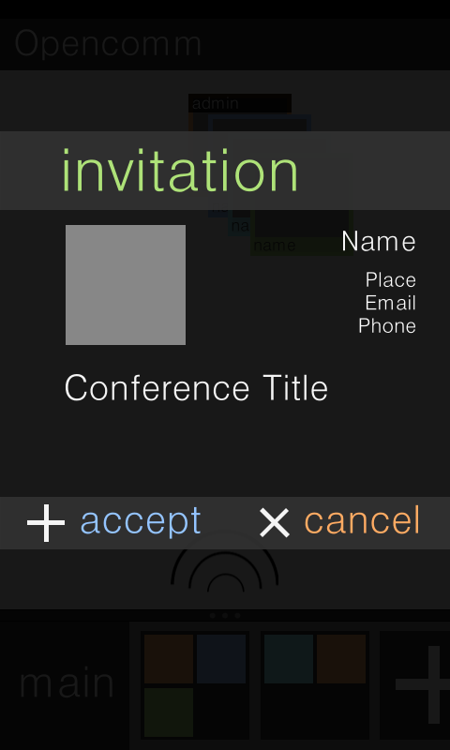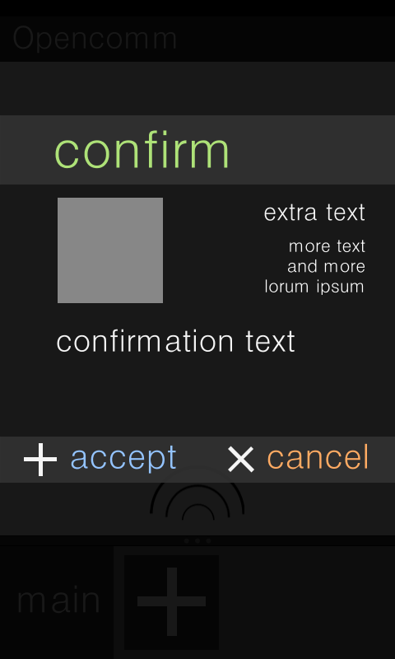

**Dialogue box (click on empty space):**

Upon holding down the empty space in the main conference or a side chat, a dialogue box should appear with the following options:

* **Add users**
* **Delete users**
* Spatialize
* Ping
* **Leave chat/conference**
* **Cancel**

The bolded options should have functionality completed by the end of the cycle while regular options should only have placeholders at this point. While only moderators can actually add users, others can send requests to moderators to add someone to the conference/chat using “Add users”.

While only moderators can delete users, it should still be displayed in the menu for all users. To indicate that it cannot be selected, this button should be grayed out.

Selecting “Leave chat” will remove the person from either the side chat or the main conference. Leaving the side chat will bring the user back to the main conversation and leaving the main conference will bring the user back to the dashboard. If a moderator is trying to leave the chat, he/she will be prompted to assign the moderator role to someone else in the chat.

Selecting “Cancel” will close the dialog box and bring the user back to the original chat/conference.

**Dialogue box (click on side chat):**

Upon holding down the boxes for the side chat, a dialogue box should appear with the following options:

* **Go to**
* **Leave**
* **Cancel**

Selecting “Go to” will bring the user into the side chat, “Leave” will remove the user from the side chat and delete the icon, and “Cancel” will close the dialog box and take the user back to the previous screen.

**Dialogue box (click on user icons):**

Upon holding down the user icons in either the side chat or the main conference, a dialogue box should appear with the following options:

* **Delete user**
* View profile
* Send message
* **Cancel**

Selecting “Delete user” will allow a moderator to remove that person from the conference or side chat. Before the user is actually deleted, there will be a confirmation sent to the moderator. As with the other three, “Cancel” will close the dialog box and take the user back to the previous screen.

**Menu button:**

When the menu button is pressed while a user is in a conference or side chat, the following options should appear at the bottom of the screen:

* Add user
* Delete user
* Settings
* **Logout**
* **Leave**

Selecting “logout” will log the user out of the application and bring the user back to the login screen. Before the users get logged out, they will have to confirm that they really want to log out and that they didn’t accidentally tap the button.

Selecting “leave” will have the same functionality as the “leave” option invoked when holding down the empty space in a conference. The user will remove the user from the conference or side chat. The user will have to confirm that he/she indeed wants to leave as well.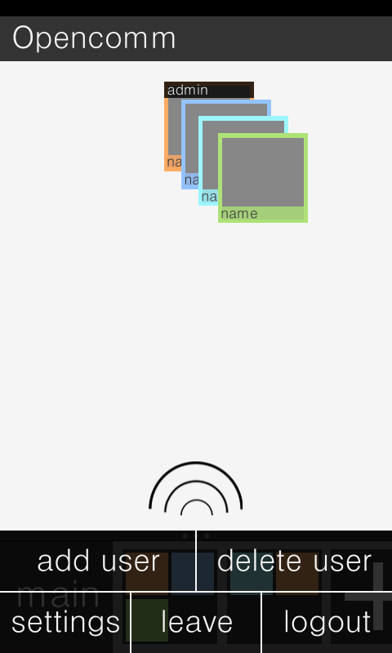

Figure 2: template for menu screen

**Tips:**

When a moderator initially creates a conference or side chat, the screen will be empty. In order to eliminate confusion for first-time or novice users, tips should appear to give directions on how to add and remove people.

Tips will appear in the same format as confirmations and will be the first thing a moderator sees when he/she creates a conference/side chat. The title should be changed to “admin tip” and the text changed to “to start adding contacts, press and hold on the background”.

For users who are not moderators, the title will simply be “tip,” and the text will be “to add contacts, just send a request to the admin. press and hold on the background to get started.”

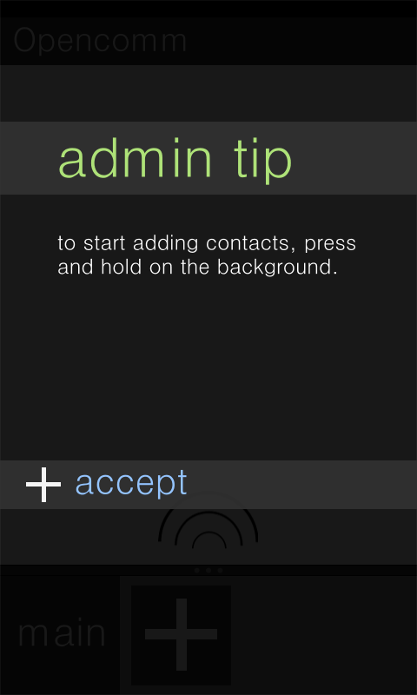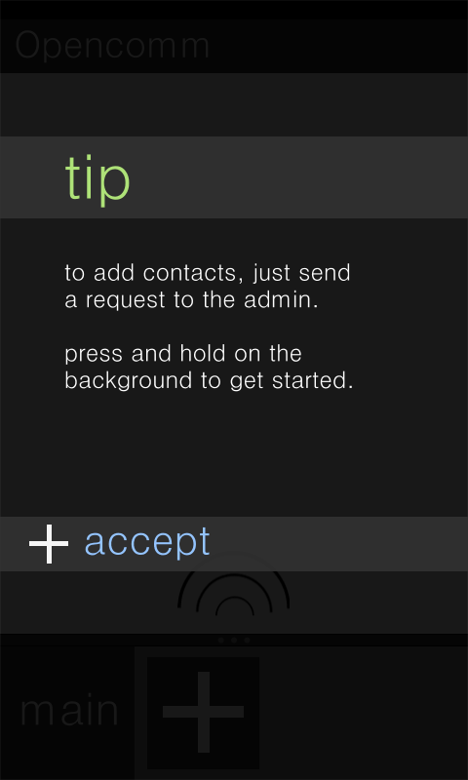

Figure 3: tips for the admin and users in a room.

Instead of having an “accept” and “cancel” button, we should only have an “accept” button. Selecting “accept” should take the user to an empty conference or side chat.

**Login:**

For this cycle, the login screen should simply allow the user to enter his/her username and password to start using the application. Usernames should be an email address the user signs up with. There should be no action bar displayed on the login screen.

Figure 4: template for login screen

**Dashboard:**

The Dashboard is the first screen the user sees once he/she logs in. This should consist of four buttons, “Start Conference”, “Contact list”, “History”, and “Account”. The “Start Conference” button should allow the user to start a new conference. If the user is already in a conference, the conference button will read, “Go to conference” instead. A user will not be able to start a new conference call if he/she is already in one. The other buttons should be put in as placeholders for this cycle.

Note that by default the user will not be in any conference when he/she logs in. The user can either be invited to a conference (the conference button will say “Go to conference”) or the user can start a new conference (the conference button will say “Start conference”). Both the arrow/plus icon and the word button (“Start conference” or “go to conference”) can be selected will take the user to a conference.

|  |  |
| --- | --- |
| A description... | A description... |
| Figure 5: template for the dashboard when the user can start a new conference | Figure 6: template for the dashboard when the user can join an existing conference |

**Action Bar:**

The stationary action bar will, for this cycle, only have the OpenComm title on the left. This title will take the user back to the dashboard. The action bar will be present on all screens aside from the login screen, invitations, confirmations, and tips.

**Backlog:**

* Login screen/some starting point for the application/dashboard
* How to turn to portrait mode
* How to handle text chat (will have to do with action bar)
* Tactile feedback
* Audio feedback
* Ways to show who is in what private space without actually having to preview all of them (via colors)
* Dragging icon directly into private space
* Search button
* Private messaging
* Overlays for preview and for where you’re going to add someone
* Auto-spatialize (reorganize icons)
* How to handle admin crashing/emergency disconnection
* Background and multitasking nature
* Handling multiple invitations
* Home screen
* Action bar items
* Menu items
* Quick and multiple delete
* Dimming of spaces that user is not currently in
* Scalable icon sizes
* Plus button on empty spaces?
* Settings + more specific setting menus
* Option to not display tips
* Emergency admin functions
* Global notifications
* Register new account
* Forgot password

**Deliverables**

* -Still based on a 480x800 screen
* -Color scheme:
  + #878787 light grey
  + #333333 dark grey
  + #F5F5F5 off white
  + #AEE278 green
  + #FFAB63 orange
  + #94C4FF blue
  + #9DF6FF teal
* Font: Datum
* Text placement is referenced from the baseline of the text
* Complete confirmations and invitations
* Dialogue box when empty space is pressed
  + Add users
  + Delete users
  + Leave chat
  + Cancel
* Dialogue box when side chat is pressed
  + Go to
  + Leave chat
  + Cancel
* Dialogue box when user icon is pressed
  + Delete user
  + Cancel
* For options that need to be completed, there should be appropriate confirmations and selection screens to complete the action
  + Ex. When user selects “Delete user” when pressing the user icon
  + Should confirm whether the user should really be deleted
* Menu:
  + Add
  + Delete
  + Settings
  + Logout (should be functional)
  + Leave conference (should be functional)
  + Look and feel:
    - Same color, text, line (size & color) settings as cycle 2
    - Entire menu bar is 480x150 pixels
    - Division lines are **off white**
    - Division lines are one third from each side on the bottom row
    - The division line between rows is halfway from the top
    - The division line on the top row is halfway from each side.
    - Background for buttons is 90% opacity black
    - Press feedback is given by a 40% white overlay on the button pressed.
* Tips:
  + Tips should be the first screen users see when they start a conference or side chat
  + Look and feel:
    - Same look and feel as confirmations
* Dashboard:
  + Start Conference/Go to conference
  + Contacts (orange)
  + History (green)
  + Account (blue)
  + Look and feel:
    - History/contact/account buttons:
      * 84 pixels high
      * Text is vertically centered on each button and font size is 47
      * Contacts button is 75 pixels from the bottom of the action bar
      * gap of 30 pixels between each button
      * Text has a left margin of 70 pixels (same indentation as the confirmation screens)
    - Conference button:
    - Look and feel is the same as the side chat bar on the conference screen
      * Height is 150px
      * Separator bar between conference button and background area is 13 pixels high
      * Dark grey button area with plus/arrow is 138x138 pixels
      * images of the arrow/plus sign will be centered on the dark grey button area.
      * “start conference”/”go to conference” has a 14px margin from the button
      * text is centered vertically in the bottom area and left justified
      * text is off-white
      * font size is 40
    - Buttons general
      * feedback for button presses will be indicated by a 40% white overlay as in the confirmation views.
* Login look and feel:
  + User input area:
    - Dark grey background
    - 400 pixels high
    - Top of the area is 100 pixels from android bar
    - “username” baseline is 86 pixels from the top of area
    - space of 24 pixels between baseline of “username” label and username field
    - username/password fields are 54 pixels high
    - Font size is 47 for “username” and “password” and 32 for user input
    - space of 100 pixels between bottom of username field and “password” label baseline
    - Labels and fields left justified with margin of 70 pixels (again, same as text in confirmation views)
  + Login button:
    - Same look and feel as conference button in the dashboard
    - Uses arrow image for button
    - Font-size for “login” is 47
    - Feedback for button press is 40% white overlay
* Action bar:
  + Selecting OpenComm will take user back to dashboard
  + Look and feel:
    - 55px from the bottom of the android bar
    - Dark grey background
    - Text is off white with font size of 28